  - Cooking Lessons
  - • Featuring Homemade S.E. Asian & American Comfort Foods

Specializing in a balanced and healthy diet with food allergen awareness and will cater to your specific dietary needs.

  - Space is limited sessions will hold up to
  - 4 persons per class.
  - All ingredients will be provided for each dish. Menu changes every class or by special requests dishes. Not required but suggested to bring your own SHARP knives and masks. This is a hands-on lesson so be prepared to get cooking!
  - Please contact me for pricing/discounts, or for specific requests.
*Tasting will be available prior to sign-in*

Featured: Call/text to make requests or for what’s cooking.

A main dish with sides or dessert

Portions will serve 2+ persons.

You’re welcome to stop by.
To find out which dishes are featured or for more info. and full menu please contact:
Phon (Fawn) call/text 360.951.0935 or by
email: ttphg80@gmail.com.
Thank you!
Mondays: 9AM-12PM
At the Hub Senior Center Kitchen
111 NE Old Belfair Hwy.
Belfair, WA 98528
Four of my Signature Dishes:
Ginger Chicken
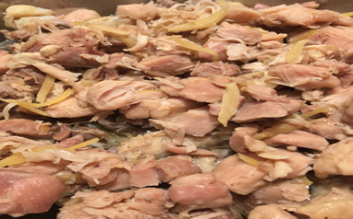

Laab/Larb (Lao/Thai Salad)
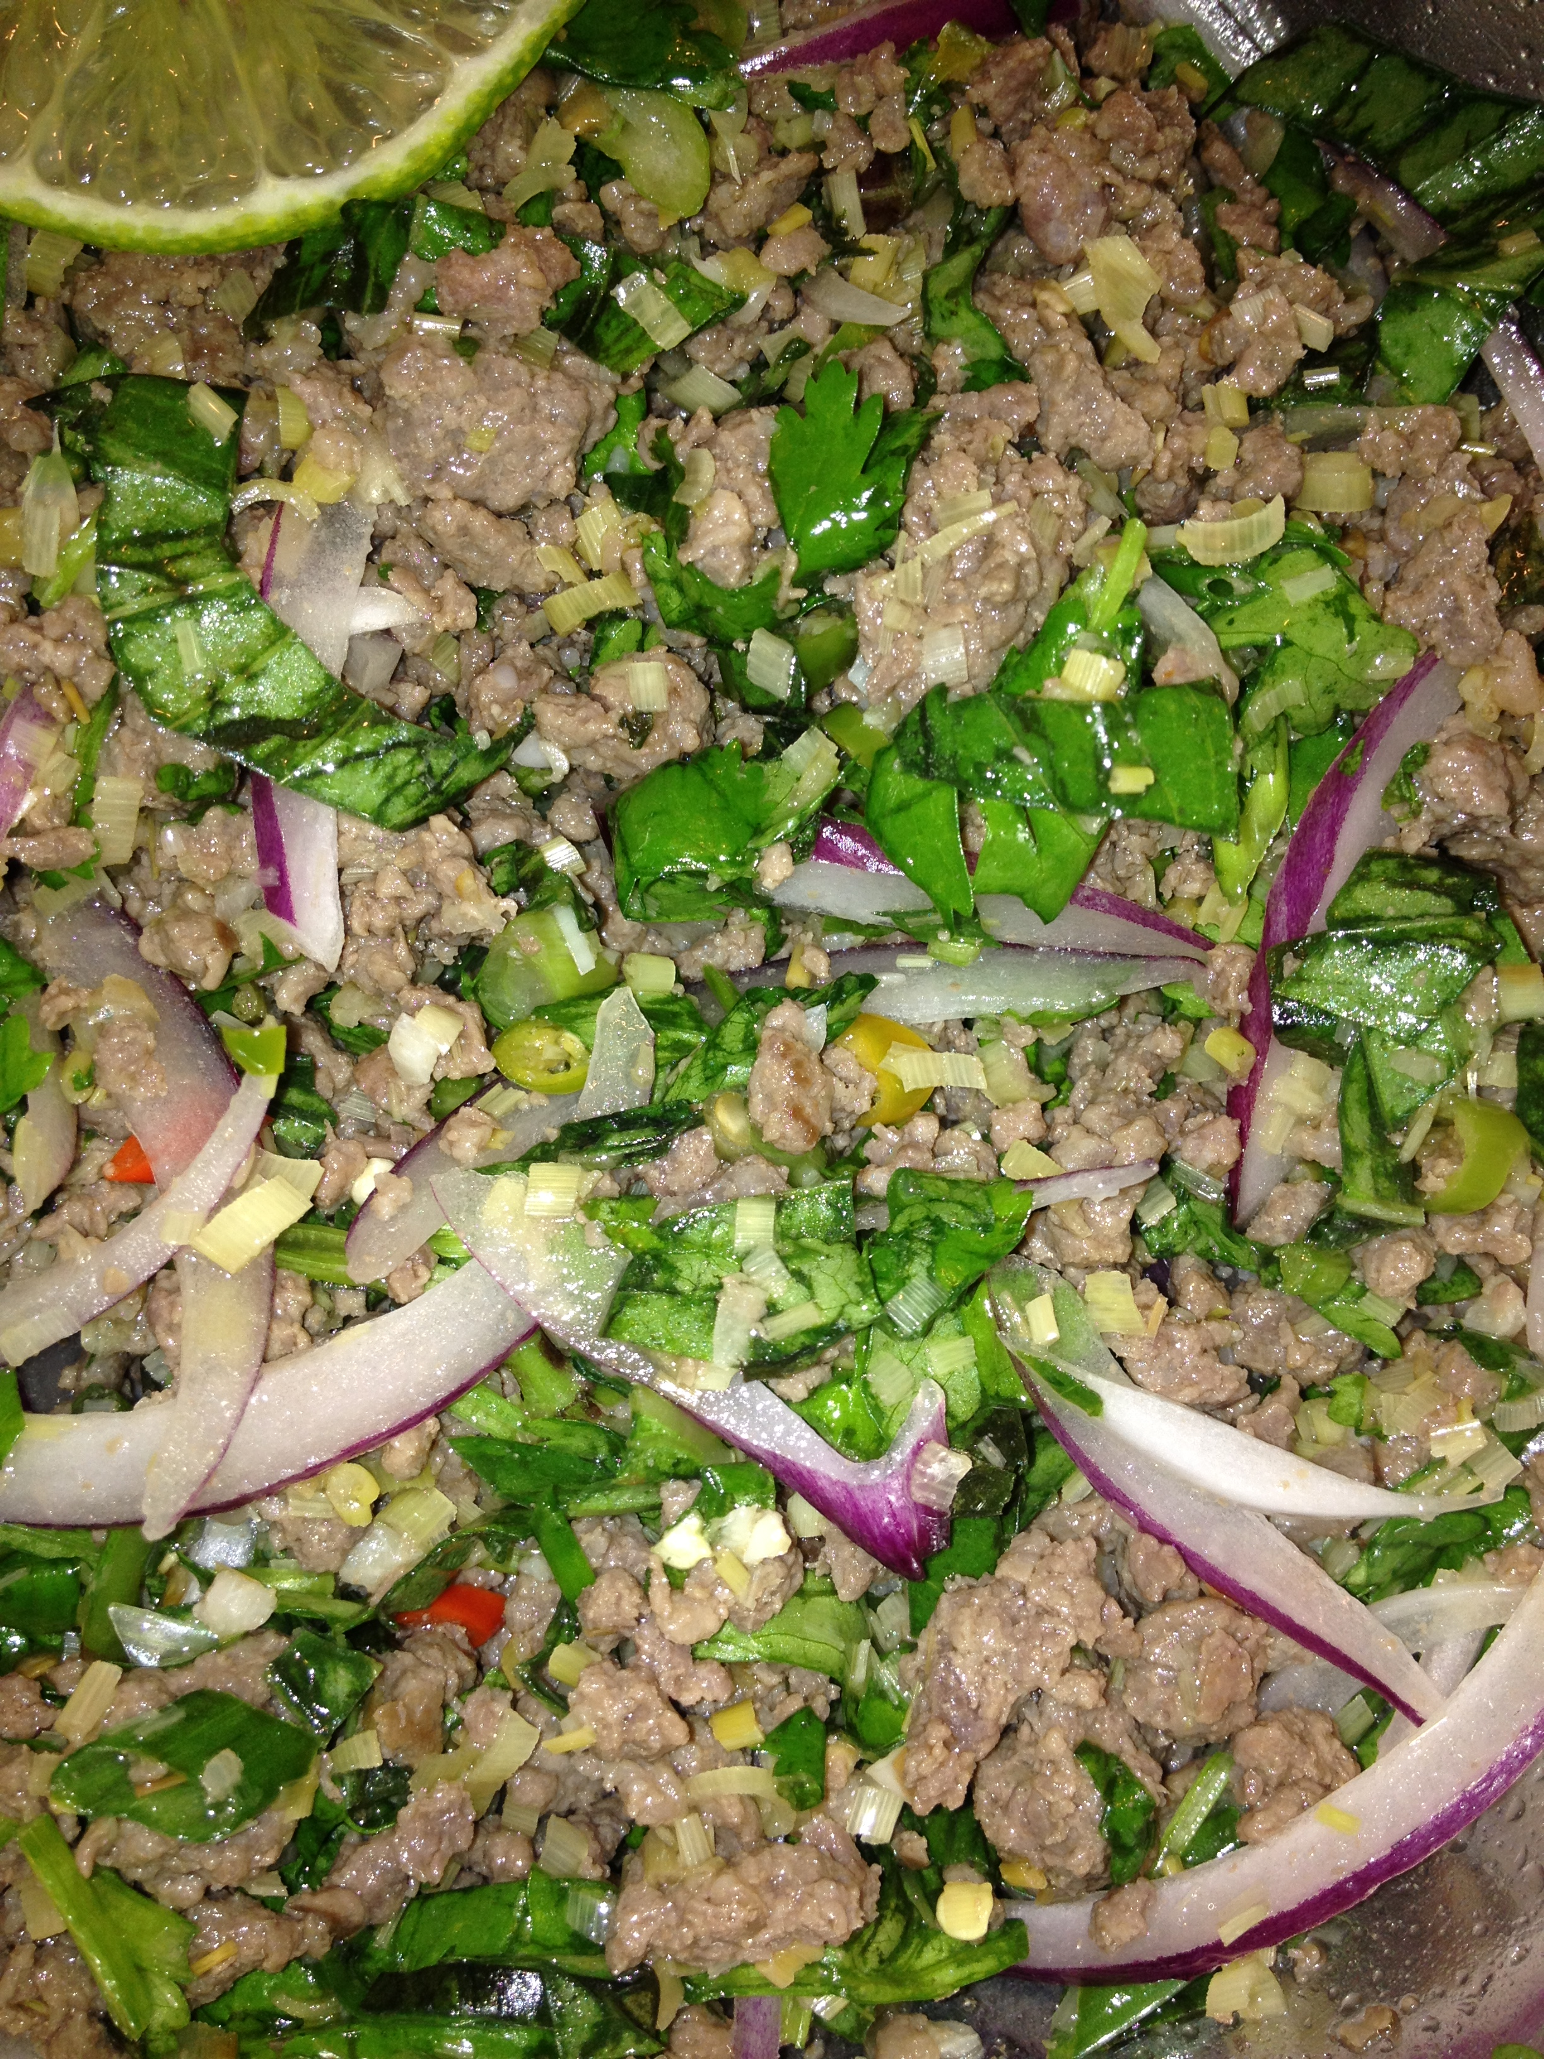

Fresh House Salsa
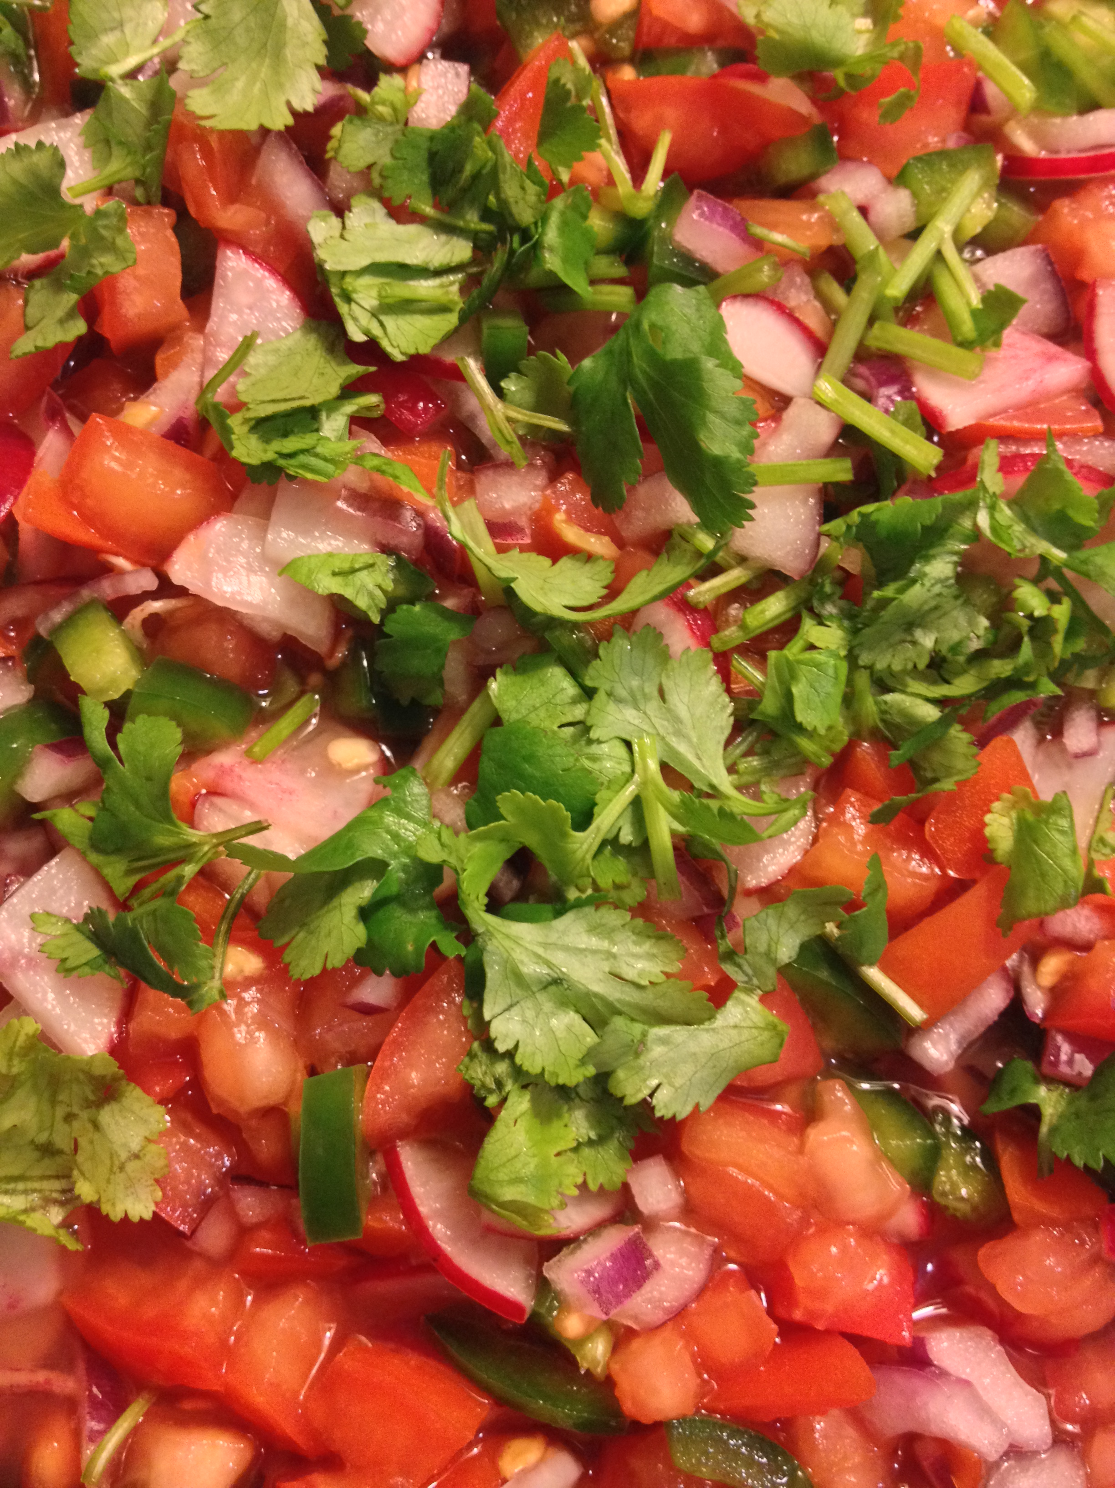

Casava Cake
